**USER PERSONAS**

**Martha Pillatt**

* Personal information:
  + Age: 23 Years old
  + Gender: Female
  + Marital status: Single
  + Residency: Kensington & Chelsea - London
* Technology competency level(use Novice, Medium or Expert):
  + App mobiles: Expert
  + Microsoft office: Expert
  + Web: Expert
  + Social networks: Expert
* Work Role: **Receptionist**
* Responsibilities:
  + Make client bookings
  + Allocate staff accord its schedule
  + Give information to the clients about the services
  + Prepare the brief of each customer for the trainers
* Personal interests/beliefs/behaviours:
  + She likes the cats
  + Eat healthy
  + Always is early
  + She is very responsible with her work and her studies.
* Any other information related to the user:
  + She lives with her mom and her grandmother
  + She study management at the university
  + She likes to go out with her friends of the university.

**John Brinkworth**

* Personal information:
  + Age: 31 years old
  + Gender: Male
  + Marital status: Married
  + Residency: Wandsworth - London
* Technology competency level(use Novice, Medium or Expert):
  + App mobiles: Novice
  + Microsoft office: Expert
  + Web: Expert
  + Social networks: Novice
* Work Role: **Account**
* Responsibilities:
  + Manage the staff salaries
  + Clients’ membership
  + Register the payments of the clients
  + Manage all cash transactions
* Personal interests/beliefs/behaviours:
  + He likes the Jazz music
  + Eat fast food
  + He likes to goes the weekend with his family to the park
* Any other information related to the user:
  + Lives with his wife and his two sons.
  + He has a grade about economics and finance

**Bill Waghorn** 

* Personal information:
  + Age: 28 years old
  + Gender: Male
  + Marital status: Married
  + Residency: Hammersmith & Fulham - London
* Technology competency level(use Novice, Medium or Expert):
  + App mobiles: Medium
  + Microsoft office: Medium
  + Web: Expert
  + Social networks: Expert
* Work Role: **Life guard**
* Responsibilities:
  + Have access to customer health details.
  + Providing first aid services
  + Safeguarding all the members in the gym
* Personal interests/beliefs/behaviours:
  + He is very athletic
  + He likes the salads and the fruits
* Any other information related to the user:
  + Lives with his wife and one dog
  + He has a grade in first aids services
  + He too work as model

**Mark Pillatt** 

* Personal information:
  + Age: 47 years old
  + Gender: Male
  + Marital status: Single
  + Residency: Richmond - London
* Technology competency level(use Novice, Medium or Expert):
  + App mobiles: Novice
  + Microsoft office: Novice
  + Web: Medium
  + Social networks: Novice
* Work Role: **Self-defence trainer**
* Responsibilities:
  + Manage their class schedule
  + Offering training services in self-defence
  + Provides customized classes to the clients
  + Share with the account department its classes schedule
* Personal interests/beliefs/behaviours:
  + He likes to trainer anybody in the Self-defence
  + He get early in his trainments
* Any other information related to the user:
  + He has 3 black belts (degree) in martial arts
  + He lives alone

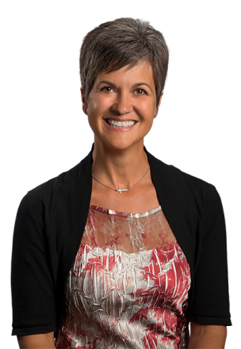**Sue Turner**

* Personal information:
  + Age: 69 years old
  + Gender: Female
  + Marital status: Single
  + Residency: Westminster - London
* Technology competency level(use Novice, Medium or Expert):
  + App mobiles: Novice
  + Microsoft office: Medium
  + Web: Medium
  + Social networks: Novice
* Work Role: **Nutritionist**
* Responsibilities:
  + Provide advice to the clients
  + Schedule appointments with the customers
  + Keep records of personal goals and the development of each customer
* Personal interests/beliefs/behaviours:
  + She is very healthy
  + She likes the instrumental music
  + She likes to read before of go to the work
* Any other information related to the user:
  + Lives with her husband and her son